**Designing For B2B Vs. B2C Websites**

By [Jenna Erickson](https://usabilitygeek.com/author/jennaerickson/)

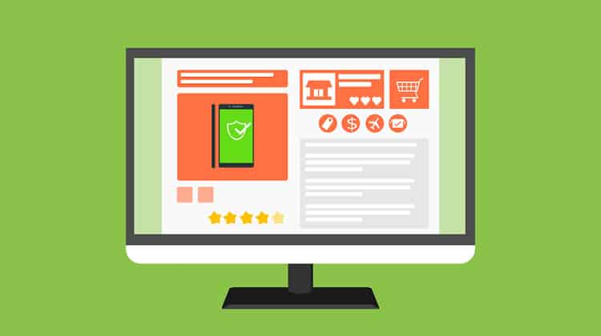

When designing an ecommerce website, it is important to note who the buyer is. Are you selling to a business, or a consumer?

Both Business-to-Business (B2B) and Business-to-Consumer (B2C) websites need to be clear and concise, need an aesthetically pleasing design, and must offer details about the product or service.

However, the needs of a consumer and the needs of a business tend to differ. As such, the amount of detail, and the UX and design needs are not consistent between B2B and B2C sites.

As a design and development shop, the company where I work, [Codal](http://www.codal.com/) caters for both B2C and B2B, coming across issues and questions all the time. From our experience, here are some of the most significant factors that you must take note of [when designing a website](https://www.interaction-design.org/literature/topics/web-design?ep=ug0) for a consumer versus a business.

**Purchase Process**

A B2C purchase process is much more simple than B2B. Typically, the transition time from being ‘just interested’ to making a purchase is much shorter. Consumers look for a convenient, smooth buying process.

Users do not want to have to register to buy something. Instead, they would prefer to put their information in and click buy. Consumers have many options in terms of where to buy something, so your website and product must stand out among competition.

A business-to-business purchase process is always a lot more complex than B2C. It has multiple stages, such as filling out a form, personal interactions, evaluation of proposals, approvals, etc. Most companies have a specific set of protocols and guidelines that must be followed. As a B2B business, we see this all the time. In order for another business to purchase from us, they need as much information as possible to pass along to others.

Unlike B2C, you should expect to always have some type of personal interaction somewhere in the process before a final purchase is made.

**Psychological Factors**

B2C purchases are routinely [associated with emotions](http://www.webstrategyplus.com/b2b-vs-b2c-marketing-sets-apart/).

Emotional triggers often guide a consumer to make a purchase. It is the feeling that the product or service gives the consumer which leads them to complete a purchase. For example, Apple’s iPhone may have the exact same features as a Samsung Galaxy phone, but it is the feeling that Apple’s branding gives the user that makes it a trendier phone.

[Branding is a huge factor in driving emotions](https://usabilitygeek.com/design-ux-ui-patterns-branding/), much more so in the business-to-consumer world, than in B2B sales.

B2B purchases can be emotional; but in a different way. People are more afraid to make a decision, because it can affect their entire team, or company. Risk aversion, and fear are two emotions that are typically associated with B2B purchases.

One bad experience can lead to a bad reputation, an unhappy team and could possibly affect other clients’ decisions through reviews and testimonials.

**Pricing Models**

B2C pricing is consistently very straightforward, clear, and upfront. Costs do not differ from consumer to consumer, unless someone has a discount code. The only hidden fee there ever is, is shipping, which is usually expected and listed somewhere on the website. Upselling and cross-selling products or services is also another common thing among B2C websites, which is very important to take note of.

B2B pricing is not as straightforward as B2C, as it can differ from company to company depending on the needs of the client. A business-to-business website usually does not list costs associated with the product or service. Commonly, B2B websites have distinct plans and various options for different types of companies, catering for a large array of sizes and industries.

B2B services and products are more challenging to price upfront on a website, considering that costs are usually customized based on company needs. Not only are costs customized, but there are often implementation, maintenance or set-fees that may not be mentioned on the website. This can sometimes be frustrating to the user because of budget approvals within a company.

Having some sort of pricing on a website can sometimes lead to a happier customer and save your sales representatives’ time by not wasting time with low-budget users.

**Buyer Decision Making**

When dealing with a business-to-consumer website, your website is only interacting with one person: the buyer / decision maker. The decision maker does not need anyone to justify their decision, or get permission to make that decision. When it is a consumer making a purchase, more likely than not the user will make an impulse decision, not necessarily planning the purchase ahead of time.

When a user is on a B2B website, there is almost always a team of people behind that individual. The multiple people involved also occasionally have to follow a set of procedures, resulting in a long and complex decision making process. B2B customers will start their research months before making a purchase.

Commonly, B2B services and products are priced higher than something listed on a B2C website. Since things tend to be pricier on a B2B website, decision makers need to be sure that the product or service will fit into their current system and workflow.

**How Does This Affect Design?**

**B2C *Web Design***

When designing a B2C website, you need to make sure the content strategy is up to par. The site will need catchy and compelling headlines. Short, yet appealing to the customer. Since the consumer is not looking for a ton of information, you do not want to overload the website with content. Minimal content, and large images will do the trick.

Since a consumer may be able to purchase a similar product on a different website, your design must be unique, and stand out among competition. The [*usability*](https://www.interaction-design.org/literature/topics/usability?ep=ug0)and user experience should consistently be updated, offering the most smooth checkout process possible.

The important journey between the user clicking ‘buy’ and actually making a payment, must have a minimal amount of steps. Product/service information must be upfront and clear, or no consumer will want to make a purchase. Keep in mind that most consumers will make their purchase on one of their first few visits, so first impression is as important as ever.

A great example that does B2C right, is [American Apparel](http://store.americanapparel.net/en/).

Image source: [American Apparel](http://store.americanapparel.net/en/)

They offer large images, with catchy and compelling headlines that are sure to make their users convert. Another great example is [ASOS](http://www.asos.com/). With more large images and compelling headlines, they know what they are doing in the B2C world.

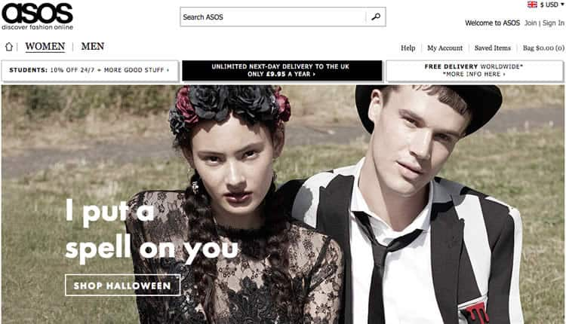Image source: [ASOS](http://www.asos.com/)

**B2B *Web Design***

Users on a B2B website are looking for as much information as possible. Your user has to completely trust the website before converting. If your website does not have valuable information and look trustable, your conversion rates will remain low.

Having a unique design is less important when it comes to a B2B website. Your design should be more focused around the content and information, making sure that the user stays informed throughout their entire journey on your website.

The design should also include a lot of CTA’s, and not just one type. Your CTA’s should include a little bit of everything: live chat, phone number, text message, and email address. Your CTAs must include some type of personalized interaction.

Your [content strategy on a B2B website](http://blog.hubspot.com/agency/differences-b2c-b2b-marketing#sm.0000a7luajmfmdlsq1c20i91g4far) should also include various types of content: whitepapers, explainer videos, testimonials, podcasts, blogs, FAQ’s, webinars, and recorded product demos. Having multiple variations of information will really help the user understand the problem that you are solving.

A purchase almost never happens on a first visit, or interaction on a B2B site. Business-to-business leads tend to need more nurturing, which is important to take into account in the design process.

Some of your content should include compatibility and integration information to assure your user that your product or service is the right fit for their company. [According to the Neilsen Norman Group](https://www.nngroup.com/articles/b2b-vs-b2c/), this is extremely important; to include technical specs, API info, and integration details.

Lastly, no matter how complicated your pricing may be, you should try to get some type of pricing model up. Even just a simple ‘Estimated Pricing Calculator’ will result in happier customers.

If you are looking for a great example of a website that does B2B right, check out [ZenDesk](https://www.zendesk.com/).

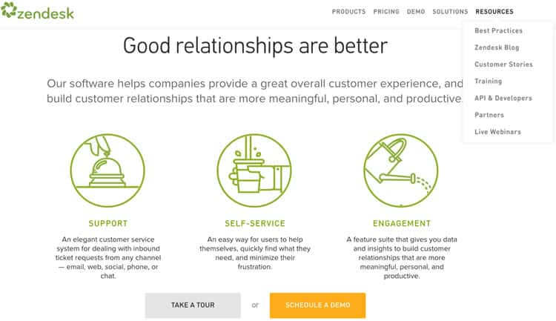Image source: [ZenDesk](https://www.zendesk.com/)

ZenDesk truly has informative information, various amount of different types of CTA’s, and features many different forms of content; webinars, blogs, demos, tours, developer information, FAQ’s, and more. They also offer the user the opportunity to view their complex pricing models.

**Conclusion**

B2B and B2C websites have different audiences, with distinct needs.

When designing for a B2B website, you must support a long, complex buying cycle with as much information as possible. On the other hand, your B2C website should have top tier [*visual design*](https://www.interaction-design.org/literature/topics/visual-design?ep=ug0), UX and *usability*.

While these things are important on every website, there should be more *emphasis* on them on a B2C website. Lastly, whenever you can, communicate prices and costs as clearly as possible.

# B2B vs. B2C Websites: Key UX Differences

**Summary:** Business-to-Business websites need to include content that is tailored to both end users and decision makers during long purchase cycles, clearly indicates integration details, has representative prices even for complex pricing scenarios, and speaks to all relevant verticals without alienating any of them.

**By**

* [Page Laubheimer](https://www.nngroup.com/articles/author/page-laubheimer/)

on May 29, 2016

**Topics:**

* [B2B Websites](https://www.nngroup.com/topic/b2b-websites/)

Business-to-business (B2B) sites have much in common with business-to-consumer (B2C) ecommerce sites: they need to [establish a clear information architecture](https://www.nngroup.com/articles/category-names-suck/), include [compelling content](https://www.nngroup.com/articles/cringeworthy-words/), offer [details about products and services that users care about](https://www.nngroup.com/articles/product-descriptions/), and have simple, understandable [interaction design](http://asktog.com/atc/principles-of-interaction-design/). In essence, nearly all of the standard user-experience principles that have been discovered for B2C apply to B2B as well. When testing B2B sites, we often hear business customers lament the usability gap between B2B sites and the better-designed consumer sites they use after hours.

However, the B2B audience often has needs that are very different from those of consumers. As a result, B2B purchases have longer decision-making phases, often significantly higher price tags, and less of a need to market based on raw product desirability.

Our research with B2B sites across a broad range of verticals has identified 5 major differences in the user-experience requirements for B2B sites and B2C sites.

## Difference 1: Content Must Support Long Purchase Decisions

B2B purchases are rarely impulsive; most commonly, they are the result of a long, complex decision-making process because they involve relatively high priced items that are expected to last for quite a while. They typically involve multiple people, across a corporate hierarchy and functional job roles. Often, customers will begin researching a purchase weeks, months, or even years before the decision is finalized. In addition, customers will share options with multiple people on their team, for research, justification, and approval purposes.

This purchase process frequently begins with one customer researching a problem faced by her company and ways to solve it. Initially, the customer may have little awareness of market segment, industry, or products, and may simply look for a solution to that particular problem. Once the user acquires an initial level of understanding, she will start researching competitors more carefully in search for the best solution.

To support B2B customers at all stages of the purchase process, you need to:

1. Provide content such as articles, blog posts, webinars, technical white papers, buying guides, or case studies that help early-stage researchers understand the types of problems you solve, how typical solutions work, and how your products or services are a key part of those solutions.
2. Ensure that your content provides criteria for why you have solved a particular problem well, so that your site visitors use those criteria as a rubric for evaluating your competitors. This type of content also helps to showcase your expertise. (Since the time of Julius Caesar, military commanders have known the advantage of choosing the battleground to suit their own army’s strengths. You should do the same. In [persuasive design](https://www.nngroup.com/courses/credibility-and-persuasive-web-design/), this concept is called framing.)
3. Acknowledge your competitor's products, and show how your solutions are better, through comparison tables (or additional text content).
4. Provide tools that enable your customers to share your content, products, and the contents of their shopping carts with other members of their team for review, discussion, and approval.

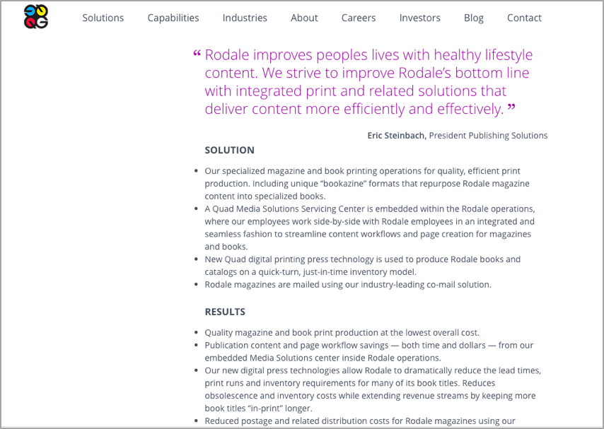Quadgraphics.com uses case studies to showcase how its expertise and products solve specific, familiar business challenges. The site structures the content into Challenge, Solution, and Results, paying attention to the details most important for their users. The bulleted format used for case studies makes this content a useful rubric for customers to check against their competitors.

## Difference 2: Integration, Compatibility, and Regulatory Information Needs to Be Clear

Many typical B2B purchases are not standalone products, but are purchased as part of a larger system that requires careful consideration of compatibility. While some B2C products (especially software or computer hardware) also have specific system requirements, compatibility is a much more prevalent consideration for B2B, as B2B customers need to ensure that new products, software, and services will fit into the existing systems and workflows used in their company. Not being able to find compatibility and integration details on a website is a major pain point for B2B customers.

Here is a small sample of the types of B2B purchases that need full compatibility or integration information:

* Software
* Printers, scanners, networking equipment, and other computer hardware and devices
* Manufacturing hardware, including robotics and controller systems
* HVAC systems, HEPA filters, and cleanroom supplies
* Engineering test equipment and automated tools
* Projectors, video walls, sound systems, speakerphones, and other visualization, presentation, and conference-room equipment
* Chemical/biotech-storage equipment, lab equipment, and test equipment
* Security systems
* Loading dock equipment, such as automated-door controls
* Retail and point-of-sale terminals and kiosks

When providing compatibility information, be sure to include:

* **Product integrations**: Name the standard products that you integrate with.
* **Versions**: Indicate the versions of those products that you integrate with (for example, if your app requires a specific edition of Salesforce, clearly specify this).
* **Feature parity**: Explicitly name the companion platform or software with which your product works best. For instance, if your product is available on both iOS and Android, but the iOS version has additional features, make that clear. Sometimes, your customers decide not only on your product, but also on other companion products at the same time, so make it clear if you have a preferred partner.
* **Technical support and integration help**: Tell your users what types of support you provide during integration or transition to a new system. Such support can be a major value add, and can build confidence that you will continue to support customers long after the purchase is completed.
* **Standards**: If you use industry standards for data exchange or physical connections, indicate the specific standard you comply with, and link to detailed information on that standard. (The link should point to the organization responsible for that standard, like IEEE, ISO, or ANSI.)
* **Physical connections for hardware**: Provide clear engineering drawings of any hardware connections, including dimensions, requirements, or proximity of other connections (such as how close ports on a server are). Specify any third-part products or typical modifications that users must make to your product to connect with other standard items. Include temperature requirements, space required for effective heat radiation, power requirements, or other environmental details, as they can have implications for installation choices in machine rooms, server closets, and such.
* **Cloud-based integration and API-support information for software**

Also remember that many industries also have strict regulations or other standards that they must adhere to. Examples include environmental requirements (e.g., RoHS), health- or financial-privacy requirements (e.g., HIPPA), import/export requirements (e.g., EAR/ECCN), or even quality-control standards (e.g., ISO 9001). For these customers, their choice of products or services will be affected by their need to comply with these standards, so provide detailed compliance information.

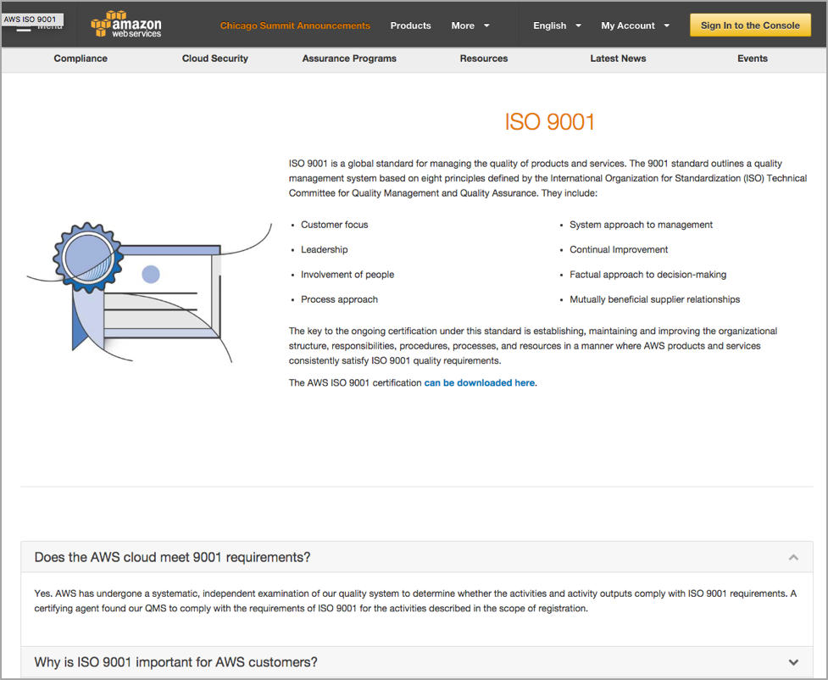Amazon's Web Services site provides a comprehensive page indicating its services’ compliance with ISO 9001 standards, details on the standard itself, the circumstances in which that standard matters, and how its services were certified.

## Difference 3: Content Should Speak to both "Choosers" and "Users"

B2B complex purchasing processes commonly involve multiple people, often at different levels of the company hierarchy. While an engineering lead may initiate the purchase of new oscilloscopes, a midlevel manager may need to approve it, an executive may have to confirm that approval, and a procurement-team member may actually purchase it. Many B2B sites go wrong by tailoring their content to decision makers, who may never actually use a product or service, and might only refer to the website as part of a final review (rather than initial research).

[Our studies revealed](https://www.nngroup.com/reports/b2b-websites-usability/) that there was typically a lot of dialogue and discussion between decision makers (known as "choosers") and key staff that actually use the products ("users") during the purchase process. Frequently, a potential “user” would become the main researcher, and would later present options to decision makers. Once this "user" decided on a favorite product, he often became a proxy or surrogate for that product, seeking [ways to justify it to his boss](https://www.nngroup.com/articles/b2b-convincing-decision-makers/) (the "chooser").

Your content must speak to both users and choosers. "Users" are often concerned with specifications and details, with the experience of using a product, and with the available support options after purchase. They also are interested in ways to justify it to their supervisors. Focus your content on answering questions about the user experience, and provide an “advocacy kit” (like brochures and PowerPoint templates) to help end users be your champions during the purchasing process.

For service-based businesses, the end users will want to read the bio pages of those team members they might interact with; your team pages should include not only executives and leadership, but also actual account reps (and others) with whom your customers will work during the engagement.

"Choosers" are typically concerned with cost, reliability, integration efforts, support contracts, and evidence that the purchase is going to provide the best possible return on their investment. ROI information, details on typical product lifespan, and information on competitive advantages speak effectively to decision makers.

## Difference 4: Complex Pricing Requires Realistic Scenarios

Most B2C products have straightforward prices that stay the same from one customer to the next, (unless there are major sales occurring or promotion codes are offered). With B2B, things aren't always so simple. The product or service may be heavily customized for each customer's needs, there can be significant quantity discounts, or customers may have relationships with account reps that allow them to negotiate favorable discounts.

As a result, pricing is not nearly as simple for B2B as it is for B2C, and in some cases, it can be very challenging to display prices. However, [B2B customers are just as price conscious](https://www.nngroup.com/articles/show-price/) as B2C customers; while price may not be the only point under consideration, it certainly is a major factor. Whenever possible, show the exact price.

If showing exact pricing is not possible, [show representative sample pricing](https://www.nngroup.com/articles/show-prices-for-common-scenarios/). Present prices in common scenarios, or provide simple price calculators. Especially in early-stage research, B2B customers will need a price range so they can begin getting budget approval; precise pricing can be confirmed later on.

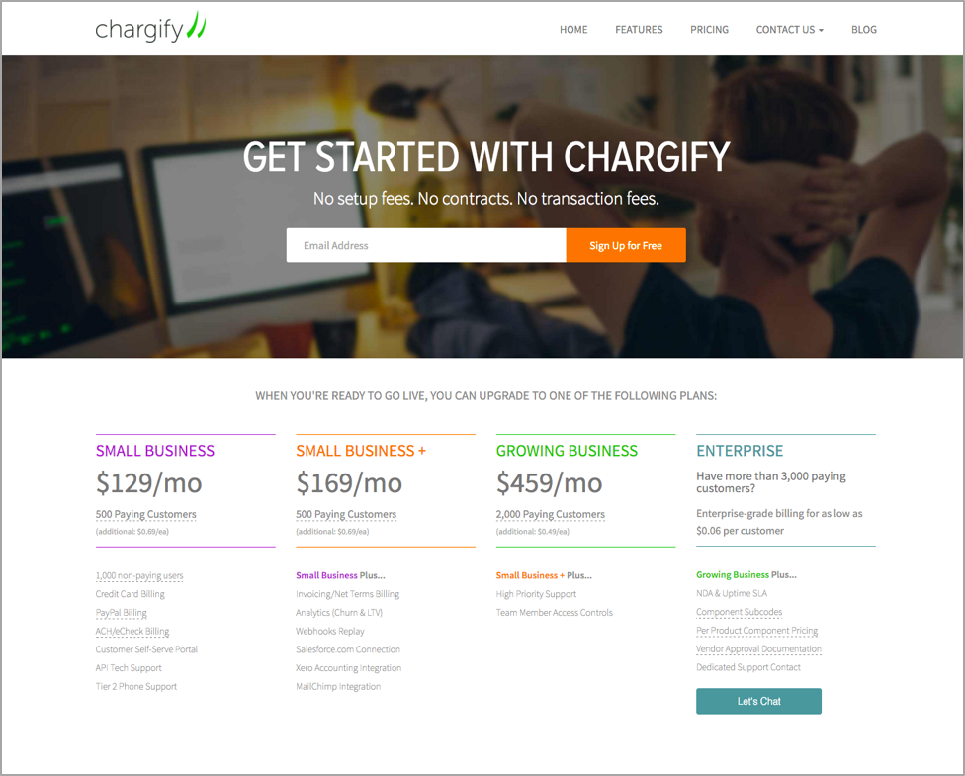Chargify shows a simple pricing chart, with only a few commonplace scenarios corresponding to different organization sizes. For large-enterprises that will require a custom contract, the site gives a ballpark price ("as low as $0.06 per customer"), and has a clear call-to-action button to have a discussion with a sales rep for a formal quote ("Let's Chat").

Showing the price can have another positive effect for your business: the price information acts as a filter, and your sales team will have to spend less time following up with leads that cannot afford your products or services. However, they may keep your product in mind as the "next step up" for when they will be able to afford you.

At the other end of the scale, if you’re very cheap but still able to serve enterprise customers, you’ll need to explain why a cheap solution can scale as required.

## Difference 5: Speak to Different Customer Segments and Scales of Businesses Without Alienating Audiences

B2B companies often need to support customers from different-size businesses, from small mom-and-pop shops to huge, multinational enterprises. This often means that some of the available offerings may not be suitable for all customer segments. In addition, a B2B site has to establish credibility with each audience, indicating how its solutions fit the problems in that industry and scale. For example, a B2B site selling security systems needs to be able to communicate whether those systems are appropriate for securing a small-business storefront during off hours, or a bank branch (and indeed the bank’s entire network of branches). These two customers are both B2B, but have very different needs, so it is critical that the site selling to them is able to help those users find the products and solutions that fit their needs.

A typical approach to this problem is to build the site's information architecture around these customer segments, using terms like For Small Business, or For National Accounts. However, [audience-based navigation can cause a myriad of problems](https://www.nngroup.com/articles/audience-based-navigation/) if these segments aren't clearly labeled (or if there is any overlap between them). For example, a huge enterprise customer might still have a small team with a specialized (and localized) need closely matches that of small-business customer. Whenever using visitor segments in navigation, ensure that they are clearly defined (i.e. define the number of employees for a small business vs. a large business), and that they are mutually exclusive.

Sharp's business site features a navigation based on customer-industry segments. Since several of these verticals overlap to some degree (such as Corporate and Legal), Sharp also provides navigation options to find products by type.

Another option is to include [filters or facets](https://www.nngroup.com/articles/filters-vs-facets/) that help users find products and services based on their needs, rather than arbitrary company size or market segments. These mechanisms allow users to identify products satisfying a range of criteria, beyond the simplistic company sizes. If you design your B2B product pages to speak to multiple segments, be cautious with large images that show products in use; if these images are too specific, they can alienate customers from other industries.

## Summary

While B2B sites have a lot in common with B2C websites, B2B audiences have distinct needs from consumer audiences. When designing a B2B site make sure that you support a complex buying cycle with content that speaks to your audience throughout the decision-making process. Clearly identify how your products integrate with other common industry solutions and include content that speaks to both the end users and the purchasing decision makers. Communicate your price (or realistic sample prices), and help users find products that fit the needs unique to companies of their size.

To learn more about designing for B2B websites, read our brand new [3rd edition B2B Website UX Report](https://www.nngroup.com/reports/b2b-websites-usability/), complete with 183 design guidelines and 249 screenshots and illustrations of specific designs that worked or failed with the users in our research.